**Product Related Demo/Promo Video Showcase Section For Shopify Site.**

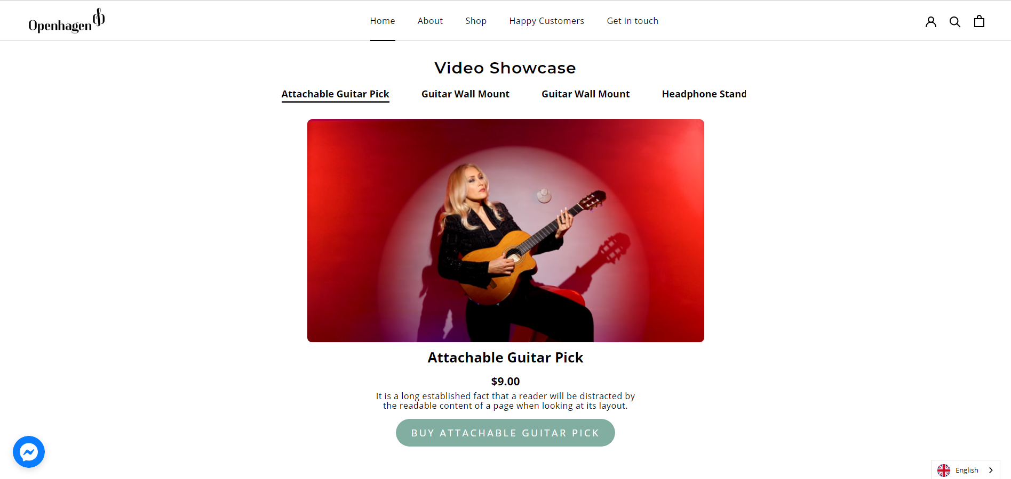

**Showcase your product Instagram reel/video on your Shopify store.**

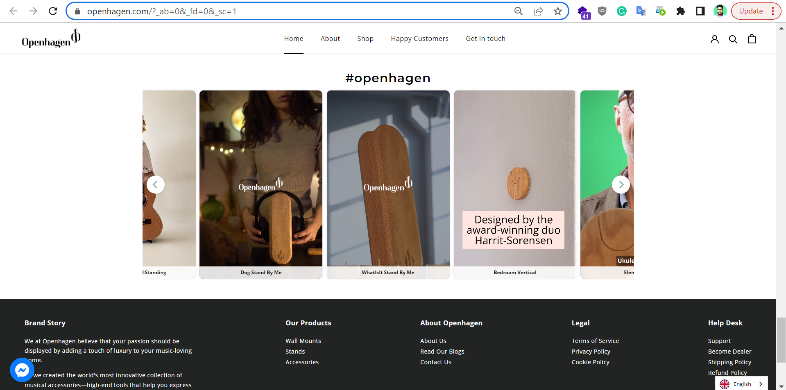

Reff Sites

<https://openhagen.com/><https://fireboltt.com/>